Lab 4

Two types of instruments for measuring the amount of Sulphur Monoxide in the atmosphere are being compared in an air-pollution experiment. It is desired to determine whether the two types of instruments yield measurements having the same variability. The following readings were recorded for the two instruments.

Instrument A

0.86 0.82 0.75 0.61 0.89 0.64 0.81 0.68 0.65

Instrument B

0.87 0.74 0.63 0.55 0.76 0.70 0.69 0.57 0.53

Assuming the population of measurements to be approximately normally distributed, test the hypothesis that  against the alternative that .

Solution:

**Descriptive Statistics**

|  |  |  |  |  |
| --- | --- | --- | --- | --- |
| **Variable** | **N** | **StDev** | **Variance** | **95% CI for σ** |
| Instrument A | 9 | 0.104 | 0.011 | (0.070, 0.199) |
| Instrument B | 9 | 0.112 | 0.012 | (0.075, 0.214) |

**Ratio of Standard Deviations**

|  |  |
| --- | --- |
| **Estimated Ratio** | **95% CI for Ratio using F** |
| 0.931228 | (0.442, 1.961) |

**Method**

|  |
| --- |
| σ₁: standard deviation of Instrument A |
| σ₂: standard deviation of Instrument B |
| Ratio: σ₁/σ₂ |
| F method was used. This method is accurate for normal data only. |

**Test**

|  |  |  |  |  |
| --- | --- | --- | --- | --- |
| Null hypothesis | | H₀: σ₁ / σ₂ = 1 | | |
| Alternative hypothesis | | H₁: σ₁ / σ₂ ≠ 1 | | |
| Significance level | | α = 0.05 | | |
| **Method** | **Test Statistic** | **DF1** | **DF2** | **P-Value** | |
| F | 0.87 | 8 | 8 | 0.845 | |

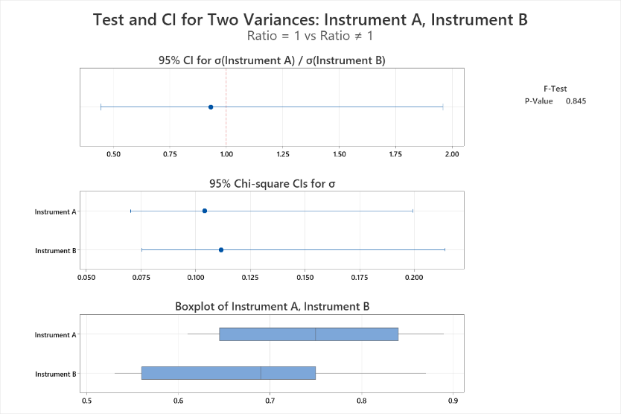

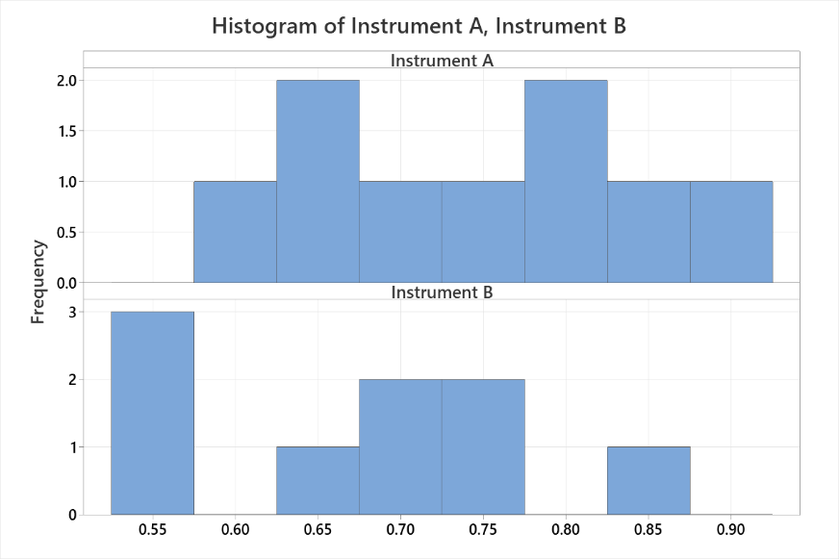

Conclusion:

1. The box plot and histogram show that the distribution of first sample is almost symmetrical but the distribution of second sample is left skewed.
2. The box plot shows that variability of two distributions is almost same, which need to confirm using the test.
3. The p-value (0.845) of the F-test way greater than the significance probability (0.05), we do not reject the null hypothesis at 5 % level of significance
4. The test result shows that the two instruments yield measurements having the same variability i.e. they are equally reliable in measuring Sulphur Monoxide in the atmosphere.